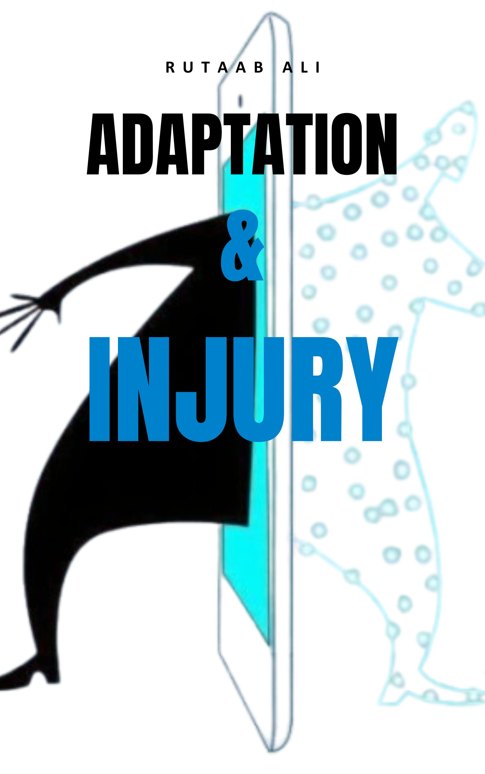

Table of Contents
Pathology 2
I. Core Concepts of Pathology 2
A. Etiology: The "Why" of Disease 2
B. Pathogenesis: The "How" of Disease Development 2
C. Structural and Functional Changes 2
D. Clinical Manifestations 3
II. Divisions of Pathology 3
III. Historical Concepts of Disease 4
Cellular Injury, Death, and Adaptation 4
I. Cellular Responses to Stress and Noxious Stimuli: Homeostasis, Adaptation, and Injury 4
Etiology of Cell Injury 4
II. Causes of Cell Injury 5
III. Mechanisms of Cell Death 6
A. Necrosis: Uncontrolled Cell Death 6
B. Apoptosis: Regulated Cell Death (Programmed Cell Death) 9
C. Other Pathways of Cell Death 11
D. Autophagy: Self-Eating 12
V. Mechanisms of Cell Injury and Common Events 12
A. Hypoxia and Ischemia 12
B. Oxidative Stress: The Free Radical Assault 14
C. Cell Injury Caused by Toxins 16
D. Endoplasmic Reticulum (ER) Stress 16
E. DNA Damage 16
F. Inflammation 16
G. Common Events in Cell Injury 17
VI. Cellular Adaptations to Stress 17
A. Specific Adaptive Mechanisms 17
1. Hypertrophy: 17
2. Atrophy: 18
3. Metaplasia: 18
4. Hyperplasia: 19
VII. Abnormal Growths and Developmental Failures 20
• Dysplasia 20
• Aplasia 20
• Neoplasia 21
• Anaplasia 21
VIII. Intracellular Accumulations and Pathologic Calcification 22
• Intracellular Accumulations 22
• Pigments 22
• Calcification 22
IX. Cellular Aging 22

Pathology
Pathology, derived from Greek words "pathos" (suffering) and "logos" (study), is the scientific discipline that links basic science and clinical practice by investigating the structural and functional changes in cells, tissues, and organs that underlie disease. It provides the foundation for understanding, diagnosing, and predicting illnesses.

I. Core Concepts of Pathology
Pathology encompasses four key aspects of a disease process:
- Etiology: The cause of the disease.
- Pathogenesis: The mechanisms of its development.
- Morphological Changes: Structural alterations in cells and organs.
- Clinical Significance: Functional consequences and manifestations.

A. Etiology: The "Why" of Disease
Etiology refers to the causal factors responsible for lesions or injury. These factors are broadly classified into two major categories:
- Genetic (Intrinsic): Such as genetic mutations or congenital abnormalities (e.g., Sickle Cell Anemia due to a hemoglobin gene mutation).
- Acquired (Extrinsic): Including infectious agents (bacteria, viruses), nutritional deficiencies, chemical exposures, and physical agents (e.g., mechanical injuries, radiation). If the cause of a disease is unknown, it is termed Idiopathic Disease.

B. Pathogenesis: The "How" of Disease Development
Pathogenesis is the sequence of events in the response of cells or tissues to a causal agent, from the initial stimulus to the ultimate expression of the disease. It describes "the mechanism by which the lesions or injury is produced." Understanding pathogenesis is crucial for comprehending the progression of a disease and assessing the damage. The time between exposure to a causative agent and the appearance of the first signs and symptoms is called the incubation period.
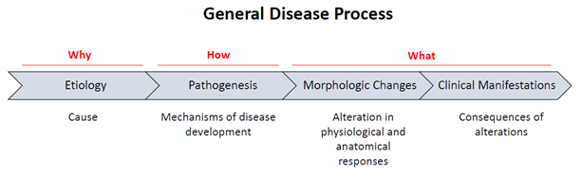

C. Structural and Functional Changes
These refer to the morphological alterations in cells or tissues and their associated functional disturbances.
- Lesion: A macroscopic or microscopic alteration in tissue resulting from injury (e.g., a bone fracture).
- Pathognomonic Lesion: An alteration that "indicates without doubt the cause of a particular disease."
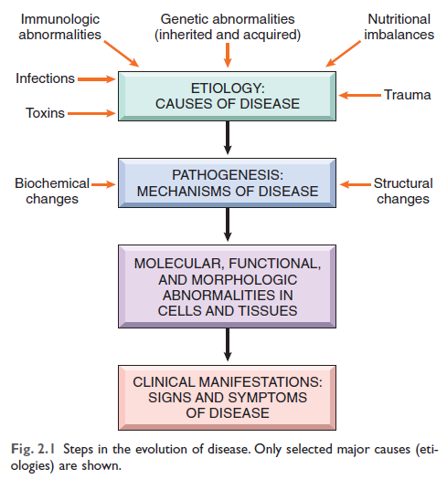
- Symptom: A clinical sign (e.g., fever, swelling, diarrhea) manifested by an individual due to tissue changes.
Morphological changes can be detected by various techniques, including:
- Macroscopic or Gross Pathology: Examination of tissue without a microscope.
- Microscopic Pathology (Histopathology): Examination of stained tissue sections with a microscope.
- Biochemical Techniques: (e.g., LFTs, RFTs, lipid profile).
- Molecular or Immunological Techniques: (e.g., PCR, ELISA).
- Imaging Techniques: (e.g., X-ray, MRI).

D. Clinical Manifestations
These are the consequences of morphological changes, influencing the clinical features (symptoms and signs), course, and prognosis of the disease.
- Diagnosis: The act of identifying a disease from its signs and symptoms, often aided by laboratory tests.
- Prognosis: A "forecast about the likely course and outcome of a disease," or "a knowing in advance" about the prospect of recovery.
- Syndrome: "A group of symptoms that occur together and characterize a particular abnormality," typical of a certain disease.

II. Divisions of Pathology
Pathology is broadly divided into:
- General Pathology: Focuses on the "basic reactions of cells and tissues to injurious stimuli," covering common and fundamental changes like cell injury and inflammation.
- Systemic or Special Pathology: Applies these basic reactions to specific body systems or diseases (e.g., pathology of respiratory, cardiovascular, or digestive systems).
- Clinical Pathology: Involves the "use of laboratory methods by clinicians to help them in arriving at a diagnosis," including examination of blood, urine, feces, exudates, skin scrapings, and biopsy material.
- Chemical Pathology: The "study of chemical alterations of the body fluids and tissue that result from disease."
- Postmortem Examination (Autopsy): Examination of a deceased individual to establish the cause of death.
- Biopsy: Examination of tissue removed from a living individual to determine the cause of disease, typically performed in suspected cancer.

III. Historical Concepts of Disease
The understanding of disease has evolved significantly over time:
- The First Concept (Demoniac): In prehistoric times, disease was believed to be caused by possession by "evil spirits or demons." This was the "demoniac concept of disease."
- The Theological Concept: Around 4000 B.C., particularly in Egypt, priests attributed illness to "Divine displeasure," believing that "if man disobeyed or displeased God, he suffered God's wrath... and became ill."
- The Humoral Concept: Proposed by Hippocrates (460-377 B.C.), this theory stated that the body consists of four humours: Blood, Phlegm, Yellow Bile, and Black Bile. Health was due to a correct mixture (eucrasia) of these fluids, while disease was caused by an incorrect mixture (dyscrasia). This was "the most important pathological theory yet propounded" and held sway until the late 19th century.

Cellular Injury, Death, and Adaptation

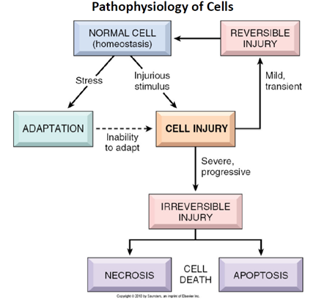
I. Cellular Responses to Stress and Noxious Stimuli: Homeostasis, Adaptation, and Injury
Cells maintain a steady state of homeostasis to meet normal bodily demands. When subjected to pathogenic insults or abnormal stimuli, cells undergo cellular adaptations to handle altered demands and maintain viability. If the stress is severe or persistent, cells may incur injuries, which can be reversible or irreversible, leading to cell death. "In 1859, Rudolf Virchow (Father of Modern Pathology) presented cellular theory of disease, stating that diseases occur due to abnormalities at the level of cells."

Etiology of Cell Injury
Causes of cell injury include both genetic and acquired factors:
- Genetic: Mutations, congenital abnormalities.
- Acquired: Hypoxia/Ischemia, physical agents (trauma, radiation, and extreme temperatures), chemical agents/drugs, microbial agents, immunologic agents, nutritional derangements, aging, psychogenic diseases, iatrogenic factors, and idiopathic diseases.
Cell injury can be categorized into two main types:
- Reversible Injury: "The cell's function and morphology can return to normal if the damaging stimulus is removed."
  - Key Morphological Signs:
    - Cellular swelling (hydropic change/vacuolar degeneration): Caused by failure of energy-dependent ion pumps, leading to water intake. Grossly, this presents as pallor, increased turgor, and increased organ weight. Microscopically, small, clear cytoplasmic vacuoles are seen.
    - Fatty change (steatosis): Appearance of triglyceride-containing lipid vacuoles in the cytoplasm, common in organs involved in lipid metabolism (e.g., liver).
    - Other changes: Plasma membrane alterations (blebbing, blunting), mitochondrial swelling, ER dilation, chromatin clumping.
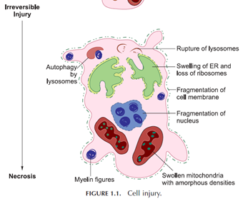
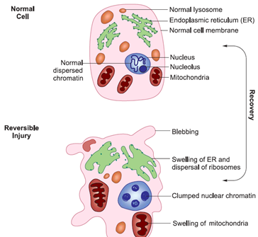
- Irreversible Injury: The cell reaches a "point of no return" and inevitably undergoes cell death.
  - Consistent Characteristics:
    - Inability to restore mitochondrial function (ATP generation).
    - Loss of integrity of plasma and intracellular membranes.
    - Loss of DNA and chromatin structural integrity.

II. Causes of Cell Injury
A diverse array of stimuli can cause cell injury, from macro-level physical trauma to single gene defects. These causes are broadly categorized as:
- Hypoxia and Ischemia: Oxygen deficiency (hypoxia) and reduced blood supply (ischemia) are the most common causes. Ischemia is more damaging than pure hypoxia due to "deprivation of oxygen to tissues relative to its needs," "inadequate supply of nutrients," and "insufficient removal of metabolites."
- Toxins: Environmental pollutants, drugs, and even normally harmless substances (e.g., glucose, oxygen) can be toxic. Toxins can be "direct-acting" or "latent," requiring conversion to reactive metabolites (often by cytochrome P-450 in the liver).
- Infectious Agents: Viruses, bacteria, fungi, and protozoans.
- Immunologic Reactions: Immune responses, while protective, can also cause damage (e.g., autoimmune diseases, allergic reactions, inflammation).
- Genetic Abnormalities: Lead to injury through protein deficiencies (e.g., metabolic errors) or accumulation of damaged DNA/misfolded proteins.
- Nutritional Imbalances: Both insufficiency (e.g., protein-calorie malnutrition) and excess (e.g., obesity leading to type 2 diabetes).
- Physical Agents: Trauma, temperature extremes, radiation, electric shock, atmospheric pressure changes.
- Aging: Cellular senescence leads to a "diminished ability of cells to respond to stress and, eventually, the death of cells and of the organism."
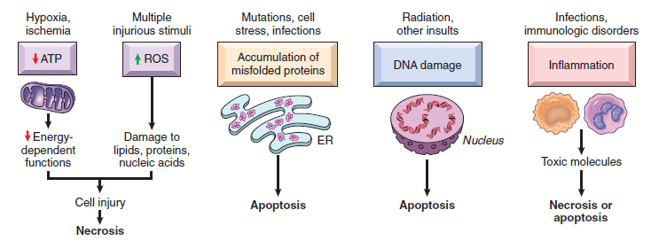

III. Mechanisms of Cell Death
When injury is severe or persistent, cells die through different mechanisms, primarily necrosis and apoptosis.

A. Necrosis: Uncontrolled Cell Death
"Necrosis is a form of cell death in which cellular membranes fall apart, and cellular enzymes leak out and ultimately digest the cell." It is an "uncontrollable form of death called 'accidental' cell death," indicating "irreversible cell injury that could not be corrected." Necrosis regularly produces a local inflammatory reaction.
- Key Features of Necrotic Cells:
  - Cell Size: "Enlargement (swelling) due to the influx of water."
  - Plasma Membrane: "Disrupted," leading to "leakage of cellular contents, including enzymes." This leakage (e.g., cardiac enzymes like creatine kinase, troponin, or liver transaminases) is a "clinically useful marker for tissue-specific necrosis."
  - Cellular Contents: "Enzymatic digestion of cellular components," by lysosomal enzymes or recruited leukocytes.
  - Adjacent Inflammation: "Frequently elicits a local host inflammatory reaction" to "eliminate cellular debris and initiate repair processes."
  - Nuclear Changes:
    - Pyknosis: Nucleus "shrinks and becomes more basophilic."
    - Karyorrhexis: The pyknotic nucleus "fragments."
    - Karyolysis: Nuclear basophilia "fades due to the digestion of DNA by deoxyribonuclease (DNase) activity."
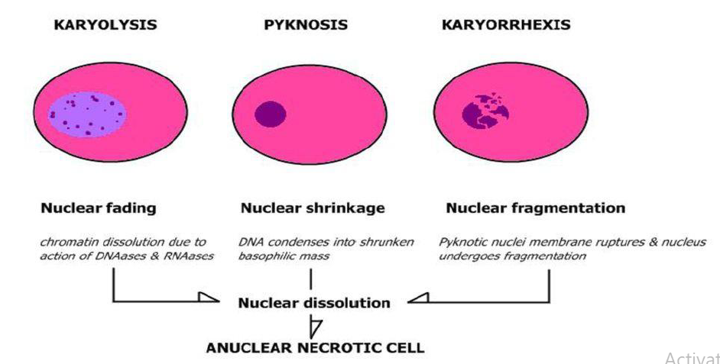
  - Cytoplasmic Changes: Increased eosinophilia (redder stain), myelin figures, and marked dilation of mitochondria with large amorphous densities.
  - Common Causes: "Ischemia (lack of blood flow), exposure to toxins, various infections, and trauma."
  - Biochemical Mechanisms: Often involve "failure of ATP generation, damage to cellular membranes (plasma and lysosomal), and irreversible damage to cellular lipids, proteins, and nucleic acids, potentially caused by reactive oxygen species (ROS)."
Morphologic Patterns of Tissue Necrosis
Large areas of tissue undergoing necrosis manifest in distinct patterns that offer "clues about the underlying cause (etiology) of the disease."
- Coagulative Necrosis:
  - Characteristics: "Preservation of the underlying tissue architecture for at least several days... The affected tissues take on a firm texture." Cells appear "eosinophilic and anucleate but their outlines may persist."
  - Mechanism: Injury denatures structural proteins and enzymes, "which prevents the proteolysis (breakdown) of the dead cells."
  - Occurrence: "Characteristic of infarcts (areas of necrosis caused by ischemia) in all solid organs except the brain."
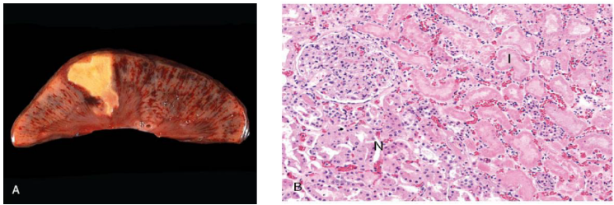
- Liquefactive Necrosis:
  - Characteristics: "Complete digestion of dead cells, transforming the tissue into a viscous liquid." If bacterial, it's "creamy yellow" pus.
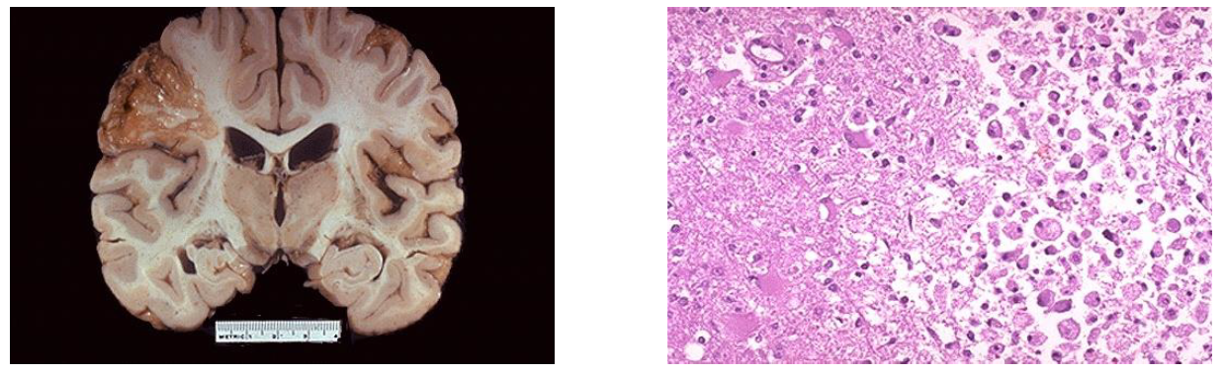
  - Mechanism: "Enzymes released by... leukocytes then digest ('liquefy') the tissue."
  - Occurrence: "Commonly observed in bacterial or fungal infections and in hypoxic injury to the brain."
- Gangrenous Necrosis:
  - Characteristics: Clinical term for a limb that has lost blood supply.
  - Progression: Initially coagulative necrosis. If bacterial infection superimposes, it becomes "wet gangrene" (liquefactive). Without infection, it's "dry gangrene," where tissue dries, shrinks, and turns black.
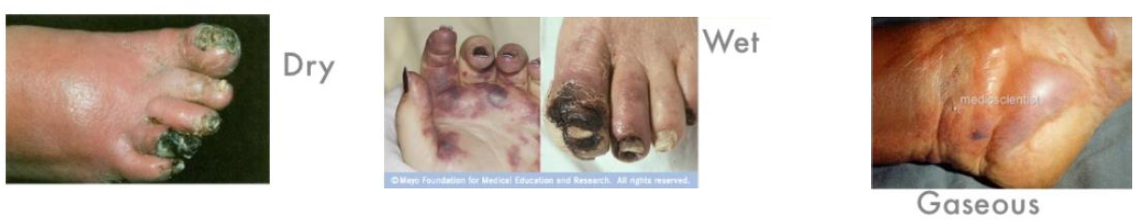
- Caseous Necrosis:
  - Characteristics: "Cheese-like," "friable, yellow-white appearance." Microscopically, "a collection of fragmented or lysed cells with an amorphous granular pink appearance."
  - Key Feature: Unlike coagulative necrosis, "the tissue architecture is completely destroyed, and cellular outlines cannot be discerned."
  - Occurrence: "Most often encountered in applications of tuberculous infection," often surrounded by a "granuloma."
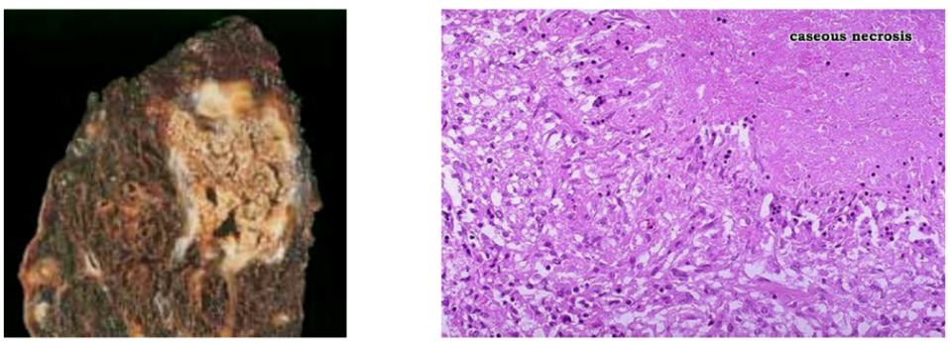
- Fat Necrosis:
  - Characteristics: "Focal areas of fat destruction." Grossly, "chalky white areas due to fat saponification (formation of calcium soaps)." Histologically, "shadowy outlines of necrotic fat cells surrounded by basophilic calcium deposits."
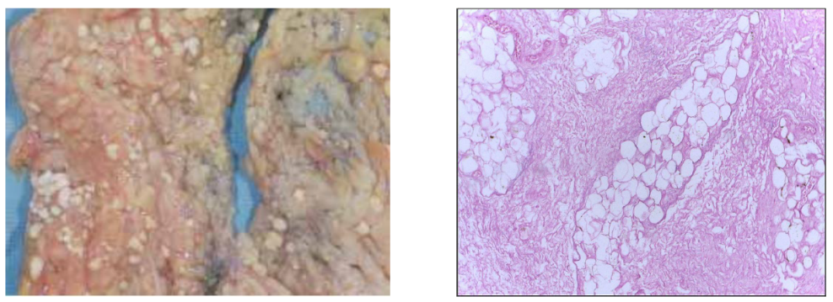
  - Mechanism: "Release of activated pancreatic lipases" which liquefy fat cell membranes and split triglycerides; fatty acids combine with calcium.
  - Occurrence: "Predominantly associated with acute pancreatitis."
- Fibrinoid Necrosis:
  - Characteristics: Histologically, "deposited immune complexes and plasma proteins leaking into damaged vessel walls produce a bright pink, amorphous appearance referred to as 'fibrinoid'."
  - Mechanism: Occurs in "immune reactions where complexes of antigens and antibodies are deposited in the walls of blood vessels." Can also be seen in severe hypertension.
  - Occurrence: "Commonly observed in immunologically mediated diseases, such as polyarteritis nodosa."
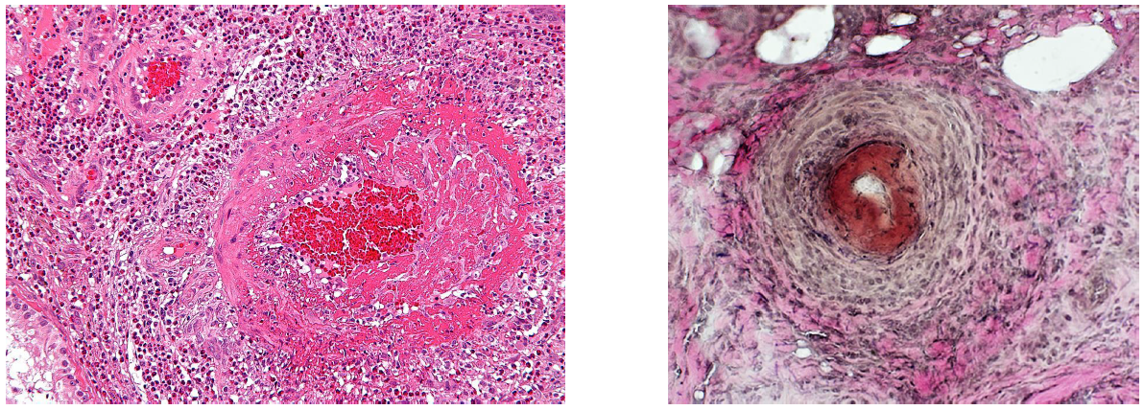

B. Apoptosis: Regulated Cell Death (Programmed Cell Death)
Apoptosis is a "regulated pathway of cell death where cells activate enzymes to degrade their own nuclear DNA, nuclear, and cytoplasmic proteins." It is a "clean" form of cell death that efficiently removes unwanted or damaged cells without eliciting an inflammatory response.
- Key Features of Apoptosis (vs. Necrosis):
  - Cell Size: Reduced (shrinkage).
  - Plasma Membrane: Remains "intact," though altered (e.g., phosphatidylserine "flips" to outer leaflet), allowing fragments ("apoptotic bodies") to be rapidly consumed by phagocytes.
  - Cellular Contents: Intact, released in apoptotic bodies.
  - Adjacent Inflammation: No.
  - Nucleus: Fragmentation into nucleosome-sized pieces (karyorrhexis, condensed chromatin).
  - Cytoplasm: Rapidly shrinks, forms cytoplasmic buds, fragments into membrane-bound apoptotic bodies.
- Causes of Apoptosis:
  - Physiologic Apoptosis: Normal process to eliminate unwanted cells (e.g., during embryogenesis, tissue turnover, involution of hormone-dependent tissues, elimination of excess leukocytes/self-reactive lymphocytes). Also called programmed cell death.
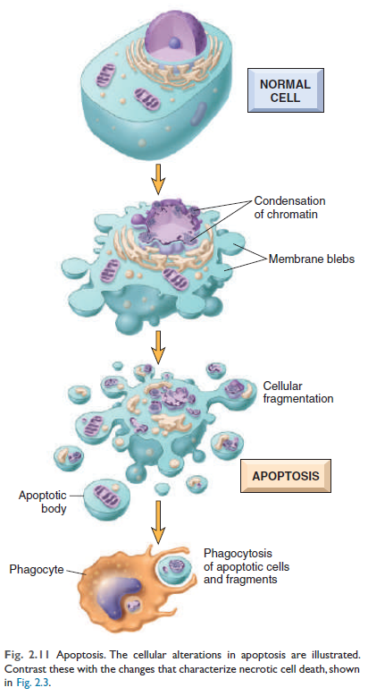
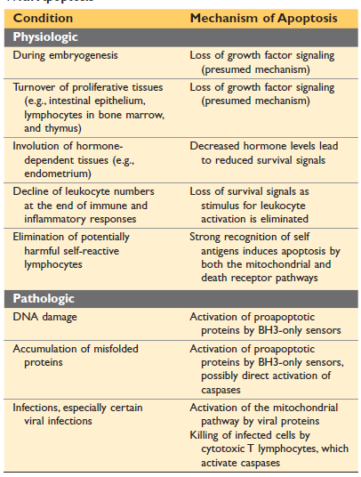
  - Pathologic Apoptosis: Eliminates cells damaged beyond repair (e.g., severe DNA damage from radiation/cytotoxic drugs, accumulation of misfolded proteins, certain viral infections).
- Mechanisms of Apoptosis: Involves the activation of enzymes called caspases. Two main pathways converge on caspase activation:
  - Mitochondrial (Intrinsic) Pathway This pathway is responsible for apoptosis in most physiological and pathological scenarios.
    - Initiation and Sensors: This pathway is triggered by various intracellular stresses, including the loss of survival signals (e.g., growth factor withdrawal), DNA damage (e.g., from radiation or toxins), and the accumulation of misfolded proteins (ER stress).
    - Role of BH3-only Proteins: In response to these stresses, a group of sensor proteins called BH3 proteins are activated. These proteins are related to the Bcl-2 family and play a critical role in shifting the delicate balance towards cell death.
    - Mitochondrial Permeability: BH3 proteins activate effector molecules, specifically proapoptotic members of the Bcl-2 family, Bax and Bak. In healthy cells, anti-apoptotic proteins like Bcl-2 and Bcl-xL maintain the integrity of mitochondrial membranes by keeping Bax and Bak in check. However, when activated, Bax and Bak dimerize, insert into the mitochondrial membrane, and form channels.
    - Cytochrome c Release and Caspase Activation: These channels increase mitochondrial permeability, causing cytochrome c and other pro-apoptotic proteins to leak from the mitochondria into the cytosol. In the cytosol, cytochrome c, along with cofactors, activates caspase-9. This initiates the caspase cascade that leads to the final steps of cell death and fragmentation.
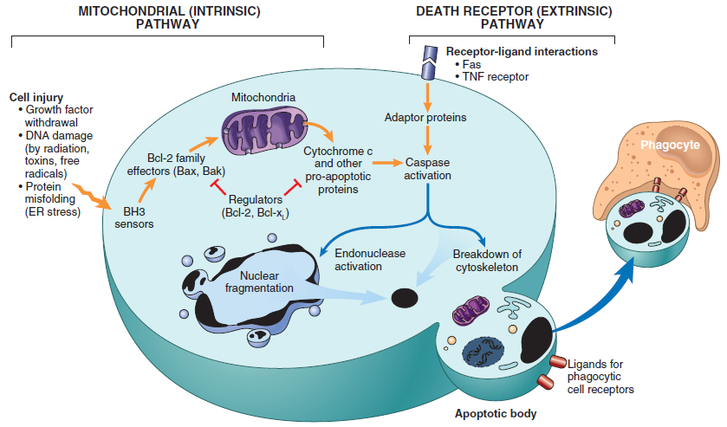
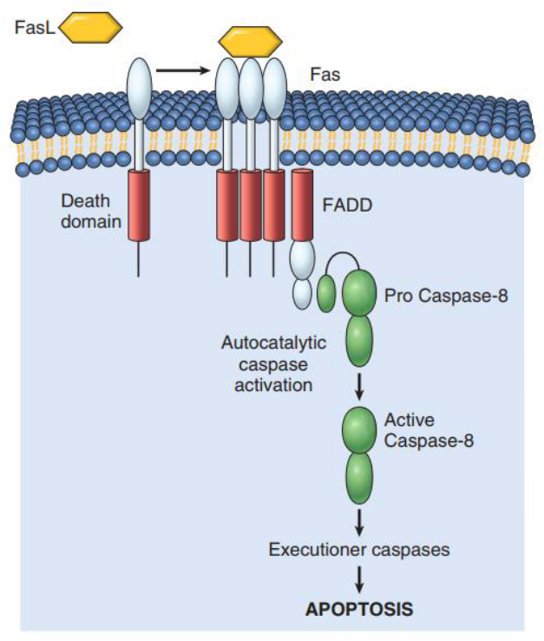
  - Death Receptor (Extrinsic) Pathway: Initiated by "engagement of death receptors (members of the TNF receptor family)" on the cell surface by ligands (e.g., FasL binding to Fas). This activates caspase-8 and downstream caspases. Involved in eliminating self-reactive lymphocytes and cytotoxic T lymphocyte (CTL) killing.
- Clearance: Apoptotic cells release "eat-me" signals (e.g., phosphatidylserine on outer membrane) to attract phagocytes for rapid and efficient removal, preventing inflammation.

C. Other Pathways of Cell Death
- Necroptosis: Shares features of both necrosis (cell dissolution) and apoptosis (regulated activation of RIP kinases). May play a role in ischemic injury and inflammatory reactions.
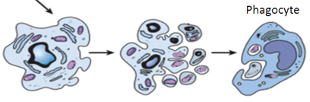
- Pyroptosis: Associated with inflammasome activation, leading to caspase activation, production of pro-inflammatory cytokines (causing fever), and cell death. Common in some microbial infections.

D. Autophagy: Self-Eating
"Autophagy ('self-eating') is a process in which the cell 'eats itself'." It is a "survival mechanism in times of nutrient deprivation," allowing cells to recycle contents. If severe, it can lead to apoptotic cell death.
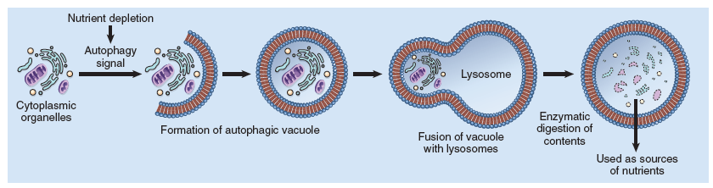
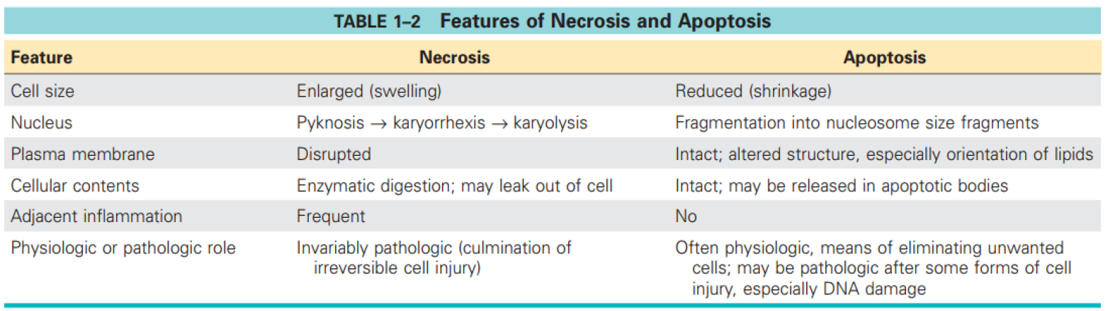

V. Mechanisms of Cell Injury and Common Events
General principles of cell injury include:
- Response depends on stimulus (duration, severity, type).
- Response depends on cell type (tolerance, genetic makeup, nutritional status).
- Injurious stimuli often target a limited number of critical cellular components and biochemical pathways.

A. Hypoxia and Ischemia
Hypoxia refers to oxygen deficiency, while ischemia means reduced blood supply. Both deprive tissues of oxygen. Ischemia is often caused by arterial obstruction and, in addition to oxygen deficiency, leads to a lack of essential nutrients and a buildup of toxic metabolites
I. Hypoxia: The Fundamental Deficiency
Hypoxia is a foundational cause of cell injury and death, defined as a "deficiency of oxygen." Its impact is broad, leading to a "shift in metabolism," "reduced cellular metabolic activity and growth," and ultimately "shrinkage or atrophy of cells and tissues."
Key Types of Hypoxia:
- Hypoxic Hypoxia: Directly due to "low oxygen levels in arterial blood."
- Anemic Hypoxia: Caused by "a low hemoglobin level in the blood," impairing oxygen transport.
- Stagnant Hypoxia: Results from "inadequate blood supply," even if oxygen levels are normal, due to poor circulation.
- Histotoxic Hypoxia: Characterized by "cellular toxicity that reduces oxygen uptake," meaning cells cannot effectively utilize available oxygen.
Common Causes of Hypoxia:
The range of scenarios leading to hypoxia in various medical emergencies and environmental exposures includes:
- Circulatory/Respiratory Failure: "Cardiac or respiratory arrest," "irregular heart rhythms or poor cardiac function after a heart attack," and "low blood pressure (shock)."
- Physical Obstruction/Suffocation: "Suffocation, choking, strangulation," and "near drowning."
- Respiratory Compromise: "Severe asthma attacks" and "complications of general anesthesia."
- Environmental/Toxic Exposure: "High-altitude exposure," "smoke or carbon monoxide inhalation," and "poisoning, drug overdose, or electric shock."
Consequences of Hypoxia:
- ATP Depletion: Oxygen deficiency impairs oxidative phosphorylation in mitochondria, leading to ATP depletion.
  - Consequences of ATP Depletion:
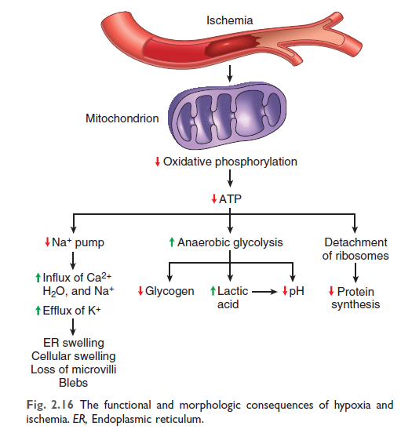
    - Reduced activity of plasma membrane ATP-dependent sodium pumps, causing intracellular sodium/water accumulation and cell swelling.
    - Increased anaerobic glycolysis, leading to lactic acid accumulation, decreased intracellular pH, and reduced enzyme activity.
    - Disruption of protein synthetic apparatus.
    - Ultimately, irreversible damage to mitochondrial and lysosomal membranes, leading to necrosis (though apoptosis can also contribute).
II. Ischemia: The More Rapid and Severe Threat
Ischemia is a more severe form of injury than simple hypoxia, characterized by "the reduction or loss of blood supply to a tissue due to obstructed arterial flow or reduced venous drainage." It can arise from "mechanical obstruction in arterial blood flow" or "a drastic drop in blood pressure or severe blood loss."
Ischemia's enhanced damaging potential stems from three synergistic pathways, causing it to "tend to injure tissues faster than hypoxia":
- Oxygen Deprivation (Hypoxia): "Hypoxia due to deprivation of oxygen to tissues relative to its needs." This is the direct link to the concept of hypoxia.
- Nutrient Deprivation: "Malnourishment of cells due to inadequate supply of nutrients to the tissue (i.e. glucose, amino acids)." This critical distinction highlights why ischemia is more damaging, as it deprives cells of essential building blocks and energy sources.
- Metabolite Accumulation: "Inadequate clearance of metabolites," leading to a buildup of toxic waste products that further impair cellular function.
III. Ischemia-Reperfusion Injury: The Puzzling Deterioration
A critical concept is Ischemia-Reperfusion Injury, where "restoring blood flow (reperfusion) to injure but still viable cells can paradoxically worsen the damage rather than repair it." This phenomenon leads to "cell death instead of recovery" and is commonly observed in conditions like "myocardial ischemia and cerebral ischemia."
The "primary cause" of this paradoxical injury is "the excessive accumulation of free radicals or reactive oxygen species (ROS)." The mechanism is "multifactorial," involving:
- Calcium Overload: "Increased intracellular calcium levels exacerbate cellular damage."
- Excessive Generation of Free Radicals: This includes potent oxidants like "superoxide, hydrogen peroxide (H₂O₂), hydroxyl radicals, and pernitrite, which cause oxidative damage."
- Inflammatory Reaction: Reperfusion "heightens inflammation by increasing the influx of leukocytes and plasma proteins." "Activated leukocytes release products that further injure tissues," and "activation of the complement system during reperfusion contributes to the injury by intensifying inflammation and tissue damage."
IV. Infarction
1. Definition of Infarction
An infarct is fundamentally defined as "an area of ischemic necrosis caused by occlusion of either the arterial supply or the venous drainage." This means it is tissue death resulting from a lack of blood supply.
2. Causes of Infarction
The primary causes of infarction involve blockages in blood vessels:
- Arterial Obstruction: This accounts for "more than 90% of cases" and leads to ischemic necrosis, where the tissue dies due to insufficient oxygen and nutrient supply.
- Venous Occlusion: Less common, primarily occurring "in organs with single venous outflow," resulting in "stagnant hypoxia" where blood flow is impeded, leading to oxygen deprivation. This is "Limited usually to congestion" in organs like the testis and ovary, with potential for bypass channels to drain blood.
Specific mechanisms leading to these occlusions include:
- Thrombus / Emboli Events: These are the "Majorly" occurring causes, involving blood clots or foreign material blocking vessels.
- Local Vasospasm: Constriction of blood vessels.
- Extrinsic Compression: Pressure from outside sources, such as "Tumor, edema etc."
- Expansion of Atheroma: "Hemorrhage within a plaque" can cause a sudden increase in plaque size, obstructing the vessel.
- Twisting of Vessels: Conditions like "Testicular torsion" can cut off blood supply.
- Traumatic Rupture: Physical damage to vessels.
3. Classification of Infarction
Infarctions are classified based on several characteristics:
3.1. According to their Color:
- Pale or Anemic Infarction: These infarcts are "due to arterial occlusion and are seen in compact organs e.g. in the kidneys, heart, spleen." Their dense tissue limits blood seepage into the necrotic area.
- Red or Hemorrhagic Infarction: These are "seen in soft loose tissues and are caused either by pulmonary arterial obstruction (e.g. in the lungs) or by arterial or venous occlusion (e.g. in the intestines)." They also occur in:
  - "Venous occlusion (e.g. Ovarian torsion)"
  - "Loose tissues or organs (such as lungs) which allow blood to be collected in infarcted zone"
  - "Tissues with dual circulation of blood (lungs, small intestines etc) allowing perfusion of blood to necrotic zone through alternative channels"
  - "Tissues previously congested with sluggish flow of blood"
  - "Sites of previous occlusion and necrosis when flow of blood is re-established"
3.2. According to their Age:
- Recent or fresh
- Old or healed
3.3. According to Presence or Absence of Infection:
- Bland: "when free of bacterial contamination"
- Septic: "when infected."
4. Morphology and Histology of Infarction
Infarcts often present with distinct morphological and histological features:
4.1. Gross Morphology:
- Wedge-shaped: Infarcts are typically "Wedge shaped," with the "Occluded vessel at the apex and the periphery of the organ is at the base."
- Fibrinous Exudate: If the "base is serosal membrane," the infarct is "Often covered with fibrinous exudate."
- Irregular Margins: "Lateral margins can be irregular depending upon the adjacent blood supply and can become distinct with the passage of time."
4.2. Histological Features:
- Ischemic Coagulative Necrosis: This is the characteristic histological change, seen in most organs "except in the brain," where it manifests as "Liquefactive necrosis."
- Inflammatory Response: An "Initial inflammatory response" occurs within "few hrs to days."
- Reparative Response: This follows from "days to weeks," often leading to the formation of "Scars."
5. Factors Influencing the Development of Infarction
Several factors determine the severity and outcome of an infarction:
- Anatomic Pattern of Vascular Supply (Availability of Alternative Supply):Dual Circulation: Organs like the "lungs, liver" have a safeguard against infarction due to multiple blood supplies.
- Anastomosing Circulation: Vessels such as the "radial & ulnar arteries" have interconnections that can provide alternative routes for blood flow.
- End Arterial Vessels: Organs like the "kidneys or spleen" have vessels that are the sole supply to a specific area, making them more vulnerable.
- Rate of Development of Occlusion: A "Slow development can give time for alternative blood supply development," which can mitigate the damage.
- Vulnerability of Tissues to Hypoxia: Different tissues have varying tolerances to a lack of oxygen:
- "Neurons" are highly sensitive, surviving only "3 – 4 mins."
- "Myocardial cells" can tolerate hypoxia for "20 – 30 mins."
- "Fibroblasts" are more resilient, surviving "till hours."
- Oxygen Content of Blood: The amount of oxygen carried by the blood also plays a crucial role in the outcome of an ischemic event.

B. Oxidative Stress: The Free Radical Assault
Oxidative stress represents "cellular damage caused by reactive oxygen species (ROS), a subgroup of free radicals." Free radicals are defined as "highly unstable chemical species with an unpaired electron, making them highly reactive." Their destructive power lies in their ability to "attack nucleic acids, proteins, and lipids in cells, initiating chain reactions that propagate damage by generating more free radicals."
1. Generation of Reactive Oxygen Species (ROS):
The balance between ROS production and removal is key. ROS are generated through:
- Normal Metabolic Activity: ROS are a byproduct of "mitochondrial oxidation-reduction reactions." Molecular oxygen is partially reduced to "superoxide (O₂⁻)," then to "hydrogen peroxide (H₂O₂)," and further to "hydroxyl radicals (OH·) via the Fenton reaction."
- Phagocytic Leukocytes: Immune cells like "neutrophils and macrophages produce ROS to destroy microbes during inflammation."
- Nitric Oxide (NO): Produced in immune cells, NO "reacts with oxygen to form peroxynitrite, a potent oxidant contributing to cell injury."
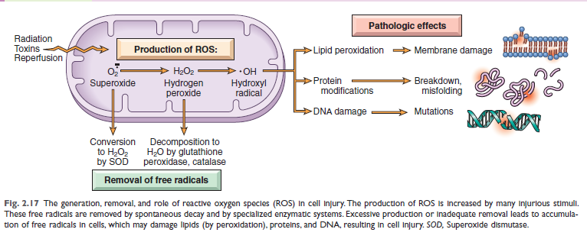
2. Circumstances Increasing Free Radical Generation:
Beyond normal metabolism, several factors significantly increase ROS production:
- Radiation Exposure: "Ionizing radiation generates hydroxyl (OH·) and hydrogen (H·) radicals."
- Metabolism of Chemicals: "Enzymatic breakdown of exogenous substances like carbon tetrachloride produces ROS."
- Inflammation: "Leukocytes release ROS during inflammatory processes."
- Ischemia-Reperfusion: As noted above, "Restoration of blood flow after ischemia triggers excessive ROS production.
3. Free Radical Removal Mechanisms (Antioxidant Defenses):
Cells possess sophisticated systems to counter ROS damage:
- Superoxide Dismutase (SOD): An enzyme that "converts superoxide (O₂⁻) to H₂O₂, accelerating its decay."
- Glutathione Peroxidase (GSH): An enzyme that "catalyzes the breakdown of H₂O₂ to water." The ratio of "GSH to oxidized GSH reflects the cell’s ability to neutralize ROS."
- Catalase: Located in peroxisomes, this enzyme "decomposes H₂O₂ into water and oxygen at an exceptionally fast rate."
- Antioxidants: Both "endogenous and exogenous antioxidants, such as vitamins E, A, and C, and β-carotene," function to "block or scavenge free radicals."
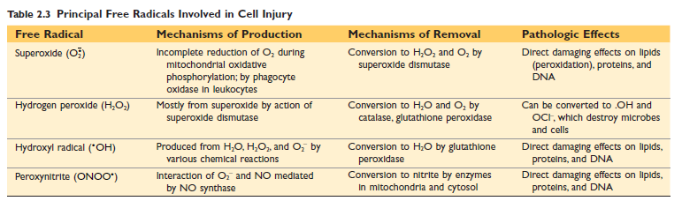
4. Cell Injury Caused By Reactive Oxygen Species (ROS):
ROS damage critical cellular components:
- Lipid Peroxidation: ROS "attack cellular membranes, leading to lipid peroxidation, which compromises membrane integrity."
- Protein Alterations: ROS cause "protein crosslinking and other structural changes, impairing protein function."
- DNA Damage: ROS "induce DNA strand breaks and modifications, disrupting genetic stability."
It is important to note that while primarily associated with injury, ROS also play a role in "various cell signaling pathways at low concentrations, influencing physiological processes."

C. Cell Injury Caused by Toxins
- Direct-acting toxins: Combine directly with critical molecular components or organelles (e.g., mercury binding to cell membrane proteins).
- Latent toxins: Must be converted to reactive metabolites (often by cytochrome P-450 in the liver) that then cause injury, frequently by forming free radicals (e.g., CCl4, acetaminophen).

D. Endoplasmic Reticulum (ER) Stress
- Accumulation of misfolded proteins in the ER triggers the "unfolded protein response."
- Adaptive response: Increases chaperones, decreases protein translation.
- Severe stress: If overwhelmed, activates pro-apoptotic sensors (BH3-only family) and caspases, leading to apoptosis via the mitochondrial pathway.
- Misfolded proteins can cause disease by protein deficiency (e.g., cystic fibrosis) or directly inducing apoptosis (e.g., Alzheimer disease, Parkinson disease).

E. DNA Damage
- Caused by radiation, chemotherapeutic agents, ROS, and mutations.
- Severe DNA damage triggers apoptosis, often via the p53 protein.
- If DNA damage is not repaired and apoptosis is bypassed (e.g., if p53 is mutated), it can lead to mutations or rearrangements contributing to cancer.

F. Inflammation
- Inflammatory reactions (elicited by pathogens, necrotic cells, dysregulated immune responses) involve inflammatory cells secreting products that damage host tissues.

G. Common Events in Cell Injury
Regardless of the cause, some abnormalities commonly occur:
- Mitochondrial Dysfunction: Leads to ATP depletion (necrosis), ROS formation, and release of pro-apoptotic proteins (apoptosis).
- Defects in Membrane Permeability: Increased permeability of mitochondrial, plasma, and lysosomal membranes is critical in necrosis.
- Mitochondrial membrane damage reduces ATP.
- Plasma membrane damage leads to loss of osmotic balance, fluid/ion influx, and loss of cellular contents.
- Lysosomal membrane injury releases enzymes that digest cell components.

VI. Cellular Adaptations to Stress
"Adaptations are reversible changes in the number, size, phenotype, metabolic activity, or functions of cells in response to changes in their environment." They allow cells to modulate structure and function to survive stress.
- Physiologic Adaptations: "Cellular responses to normal stimulation," such as hormonal changes (e.g., enlargement of breast and uterus during pregnancy).
- Pathologic Adaptations: "Cellular responses to stress, enabling cells to adjust their structure and function to avoid injury, often at the cost of normal function" (e.g., squamous metaplasia in smokers).

A. Specific Adaptive Mechanisms

Hypertrophy:
- Definition: "An increase in the size of cells, resulting in an increase in the size of the affected organ."
- Mechanism: "Larger cells having increased amounts of structural proteins and organelles." It is the "primary response in cells with limited capacity to divide."
- Causes:
  - Physiologic: "Increased skeletal muscle volume in athletes/body builders," "enlargement of the uterus during pregnancy," and "breast tissues during lactation."
  - Pathologic: "Hypertrophy of cardiac muscle (due to hypertension or aortic valve disease)" and "hypertrophy of smooth muscle."
- Can progress to cell injury if stress is not relieved (e.g., cardiac failure).
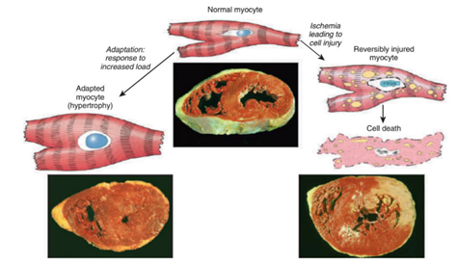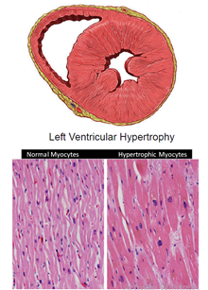

Atrophy:
- Definition: "The shrinkage of cell size due to the loss of cell substance." If enough cells are affected, the "entire tissue or organ may become smaller." Atrophic cells are diminished in function but not dead.
- Causes: "Decreased workload," "loss of innervation," "reduced blood supply," "poor nutrition," "loss of endocrine stimulation," and "aging (referred to as senile atrophy)."
- Cellular Mechanism: "Combination of decreased protein synthesis and increased protein degradation," primarily through the "ubiquitin-proteasome pathway." Often accompanied by "autophagy."
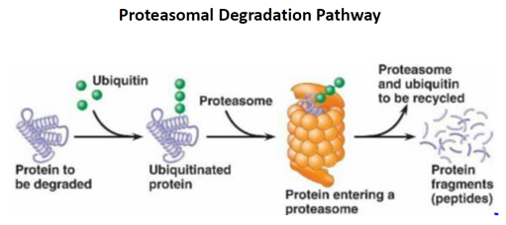
  - This ubiquitin-proteasome pathway is activated by nutrient deficiencies or disuse, where ubiquitin ligases attach ubiquitin peptides to cellular proteins, targeting them for breakdown in proteasomes. This pathway is also implicated in accelerated protein degradation during catabolic conditions, such as cachexia associated with cancer.

Metaplasia:
- Definition: "A reversible change in which one adult cell type (epithelial or mesenchymal) is replaced by another adult cell type."
- Purpose: A cell type "sensitive to a specific stress is replaced by one better suited to endure the adverse environment."
- Mechanism: Believed to arise from "reprogramming of stem cells, which differentiate along a new pathway.”
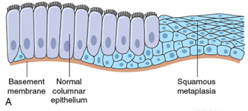
- Examples:
  - Epithelial: In smokers, ciliated columnar respiratory epithelium replaced by "stratified squamous epithelial cells." In chronic gastric reflux, esophageal stratified squamous epithelium replaced by "gastric or intestinal-type columnar epithelium" (Barrett esophagus).
  - Mesenchymal: Can occur (e.g., bone formation in soft tissues after injury), but is typically a "response to pathologic alterations rather than an adaptive response.”
- Risk: If stimuli persist, metaplasia "can increase the risk of malignant transformation."

Hyperplasia:
- Definition: "An increase in the number of cells in an organ or tissue, resulting from enhanced proliferation... Requires cell populations capable of replication." Driven by "growth factors."
  - Physiologic:
    - Hormonal (e.g., "proliferation of glandular epithelium in the female breast during puberty and pregnancy")
    - Compensatory (e.g., "remaining tissue regenerates after the loss of part of an organ," like liver).
  - Pathologic:
    - "Excessive hormonal or growth factor stimulation" (e.g., endometrial hyperplasia, benign prostatic hyperplasia) or "viral infections" (e.g., papillomaviruses leading to warts).
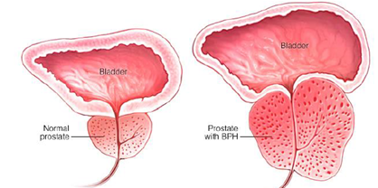
    - "Pathologic hyperplasia is controlled but can be a fertile soil in which cancers may eventually arise."

VII. Abnormal Growths and Developmental Failures
Beyond reversible adaptations, cells can exhibit more severe deviations:
- Dysplasia: "Disordered cellular development and is often associated with metaplasia or hyperplasia." "Commonly occurs in epithelial cells." Characterized by "loss of cellular uniformity and architectural orientation," including increased cell layers, disorderly arrangement, and loss of polarity, pleomorphism (variation in size/shape), increased nucleocytoplasmic ratio, hyperchromatism, and increased/abnormal mitotic activity.
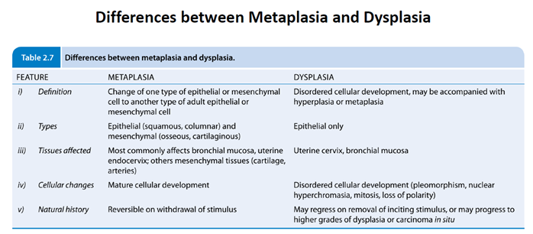
- Aplasia: "An extreme failure of development where an organ or tissue is entirely or largely absent due to a defect in the developmental process."
  - Examples of Aplasia:
- Acquired Pure Red Cell Aplasia (PRCA)
- Aplasia Cutis Congenita
- Radial Aplasia
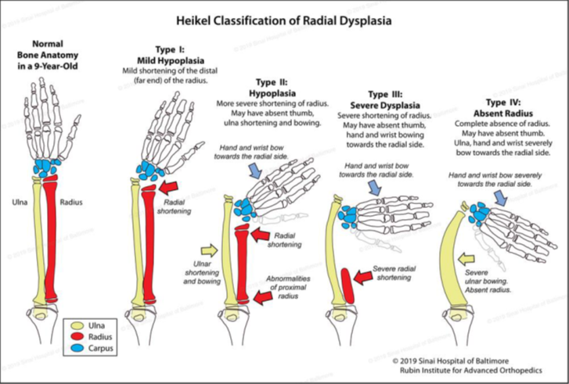
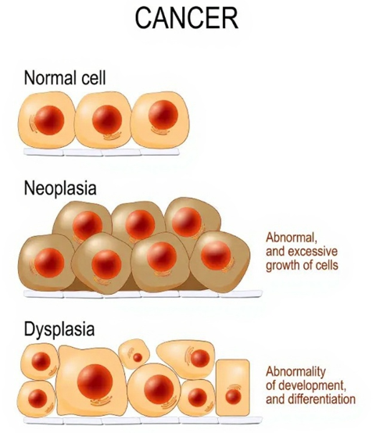
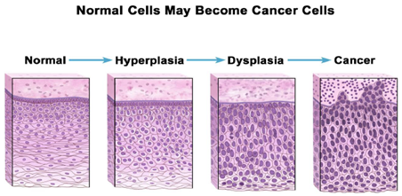
- Neoplasia: "The process of 'new growth,' and the resulting abnormal growth is termed a neoplasm." Willis's definition: "An abnormal mass of tissue, the growth of which exceeds and is uncoordinated with that of normal tissues and persists in the same excessive manner even after the stimuli that initiated the change have ceased." Can be "benign or malignant," well or poorly differentiated.
- Anaplasia: Meaning "to form backward," it refers to "a loss of differentiation in cells, signifying a reversion from a high level of specialization to a lower level." It is a hallmark of malignancy. Morphological changes include significant pleomorphism, abnormal nuclear morphology (hyperchromatic, "Irregularly shaped" nuclei, increased nucleocytoplasmic ratio from normal 1:4/1:6 to "1:1”, enlarged nucleoli, and aneuploidy: abnormal number of chromosomes), high rate of atypical mitoses, and polymorphic or multiple nuclei.

VIII. Intracellular Accumulations and Pathologic Calcification
Cells can accumulate abnormal amounts of various substances.
- Intracellular Accumulations:
  - Fatty Change (Steatosis): Triglyceride accumulation within parenchymal cells, common in liver (e.g., alcohol abuse, diabetes). Reversible.
  - Cholesterol and Cholesteryl Esters: Overload in phagocytic cells (e.g., atherosclerosis).
  - Proteins: Less common; due to excesses or excessive synthesis (e.g., reabsorbed albumin in kidney tubules, immunoglobulins in plasma cells).
  - Glycogen: Excessive deposits due to abnormal glucose/glycogen metabolism (e.g., diabetes, glycogen storage diseases).
- Pigments:
  - Carbon (exogenous): Air pollutant, phagocytosed by macrophages, causing anthracosis (blackening of lymph nodes/lungs).
  - Lipofuscin (endogenous): "Wear-and-tear pigment," brownish-yellow granular material from lipid peroxidation. Accumulates with aging/atrophy, a marker of past injury, not directly injurious.
  - Melanin (endogenous): Brown-black pigment synthesized by melanocytes.
  - Hemosiderin (endogenous): Hemoglobin-derived golden yellow to brown pigment, aggregates of ferritin micelles. Accumulates with excess iron; excessive deposition called hemosiderosis.
- Calcification: Abnormal deposition of calcium salts and other minerals.
  - Dystrophic Calcification: Occurs in "injured or dead tissue," with normal calcium metabolism. Common in areas of necrosis (e.g., caseous necrosis in tuberculosis, aging heart valves, advanced atherosclerosis). Can lead to organ dysfunction.
  - Metastatic Calcification: Occurs in "normal tissues" but is associated with hypercalcemia. Major causes include increased parathyroid hormone, bone destruction (tumors), vitamin D disorders, and renal failure. Can occur widely but principally affects vasculature, kidneys, lungs, gastric mucosa.

IX. Cellular Aging
"Individuals age because their cells age." Aging is a significant risk factor for chronic diseases, a regulated process influenced by genes and signaling pathways.
- Accumulation of mutations in DNA: DNA damage from metabolic insults and ROS accumulates over time, especially if repair mechanisms decline.
- Decreased cellular replication (Replicative Senescence): Normal somatic cells have a finite number of divisions before entering a non-dividing state.
- Caused by progressive shortening of telomeres, the protective ends of chromosomes. Telomere shortening also impacts stem cell regenerative capacity.
- Telomerase, an enzyme maintaining telomere length, is absent in most somatic cells but expressed in germ cells and stem cells, and reactivated in cancer cells.
- Defective protein homeostasis: Cells struggle to maintain normal protein balance due to increased turnover, decreased synthesis, and defective chaperones/proteasomes, leading to misfolded protein accumulation and apoptosis.
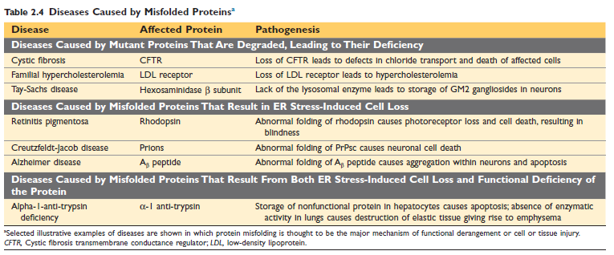
- Persistent inflammation: Accumulation of damaged substances activates inflammasomes, leading to low-level chronic inflammation, contributing to diseases like atherosclerosis and type 2 diabetes.
- Counteracting Aging: Calorie restriction and physical activity can slow aging by altering signaling pathways and improving immunity.

